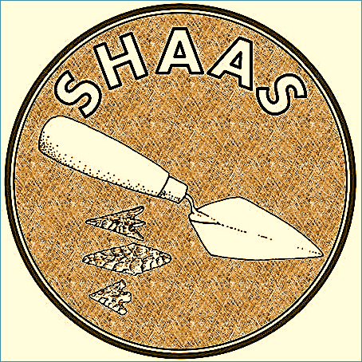
Southborough & High Brooms Amateur Archaeology Society
MEMBERSHIP FORM
1 April 2016 – 31 March 2017
If you would like further information about what the society has set out to achieve please contact: info@southborougharchaeology.org
Please fill in the application form and return it to the email address above.
Name
Age | under 18 ☐ 18 – 29 ☐30 – 45 ☐ 46-65☐ 65+ ☐
Gender (please tick) | Male ☐ Female ☐
Address for correspondence
Email (BLOCK CAPITALS)
Phone
Have you been part of an archaeological excavation before? Please give details.
Are there any limitations (health or other) of which SHAAS needs to be aware?
How did you hear about SHAAS?
Membership fee ☑  Individual £5 ☐  Family £10 ☐  Please note that children need to have a parent/guardian with them at all times | Cheque enclosed for £ ……………  BACS for £………………. Transferred date ……………………..  SHAAS a/c 65772852 Sort code 08-92-99  Family membership - No of Adults …… No of Children ……

I agree for my personal/family details to be used for SHAAS admin. I permit/do not permit any photographs of myself/family on SHAAS events to be used for SHAAS publicity purposes.

Signed: _______________________________________ Date: ___/___/____

